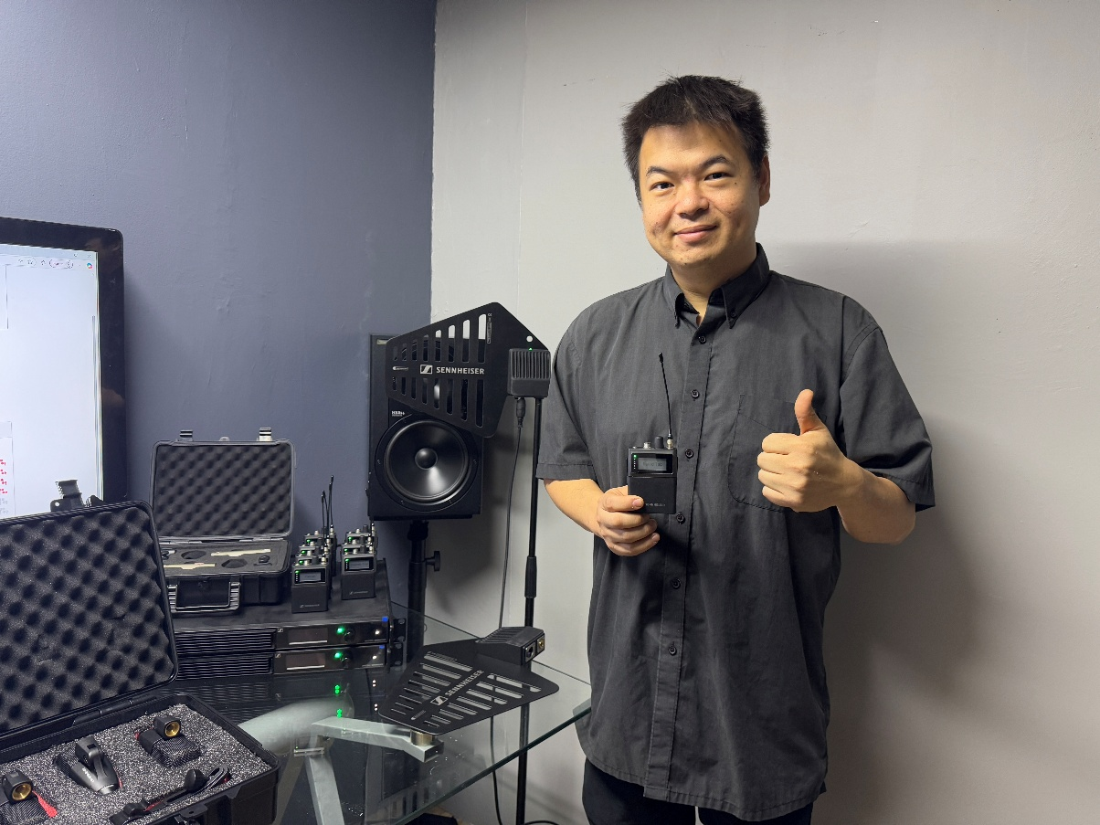
Favian Ngan, founder of AV Production and touring monitor engineer

AV Production uses Sennheiser Spectera to bring control and clarity to touring

Singapore, March 2026 –Singapore-based AV Production (AVP) is a production house specialising in concert productions and festivals. Beyond event services, AVP’s founder, Favian Ngan, is also an active touring monitor engineer and works with many leading Asian artists. This dual role gives Favian a unique perspective, balancing long-term system design with the fast-paced demands of large-scale live touring.

Currently serving as monitor engineer on a major international world tour with more than 70 shows completed, Favian operates in some of the most demanding live sound environments. From large indoor arenas to outdoor stadiums with expansive stages and catwalks, delivering stable and consistent in-ear monitoring has become increasingly complex, particularly as the RF spectrum grows more congested and often becomes unpredictable across international touring circuits.

When industry standards reach their ceiling
Like many touring engineers, Favian’s workflow used to rely heavily on industry-standard analogue IEM systems. While dependable for years, these systems were increasingly strained by modern production demands.

“In many venues, the RF environment has become increasingly challenging, with noise floors rising to unpredictable levels,” Favian explains. “A frequency that appears clean during soundcheck can suddenly become unusable during the show. Modern concerts often incorporate extensive LED walls, LED light sticks, effect lighting, and even anti-drone jammers, all of which contribute to this instability.”

Managing large channel counts across wide stages often meant constant troubleshooting, especially when artists moved freely across the performance area or into the audience. At the same time, older systems in his inventory were due for renewal, prompting Favian to look for a solution that could move beyond the limitations inherent to analogue wireless.

Early adoption on the world stage
During an industry event, Favian was introduced to Spectera by Darryl Tan, Business Development Manager at Sennheiser.

“He told me that a powerful new wireless system would be launching soon, and that it would be well suited for a production company like mine,” Favian recalls. “Because it caters to touring production requirements in a very small form factor, he felt it would make a real difference to how we tour with gear on the road.”

As part of this early engagement, Favian became one of the customers under the Spectera Pioneer Programme. Ahead of the official launch, Darryl brought a demo set to Favian and facilitated hands-on demos, technical briefings and on-site support to ensure the system could be deployed confidently in a demanding touring environment.

“Spectera uses WMAS technology and it was something completely new to me,” Favian says. “It was also positioned as a very different system, so I wanted to hear it and test it for myself.”

Listening tests immediately revealed a noticeable improvement in audio quality. Yet the true measure of performance lay in RF stability and usability, factors that could only be validated under the demanding conditions of live touring. The system’s first deployment took place at a major stop of the tour in an 80,000-seat Olympic sports stadium, beginning with rehearsals and culminating in its use during the live performance itself.

Redefining RF coverage for large stages
One of Spectera’s most immediate advantages was its multi-antenna capability. Unlike analogue systems, which typically rely on a single antenna for IEMs, Spectera allows up to four antennas to operate simultaneously.

“Our stages can be over 120 metres wide with central catwalks,” Favian explains. “With analogue systems, there is no perfect antenna position. You are always compromising.”

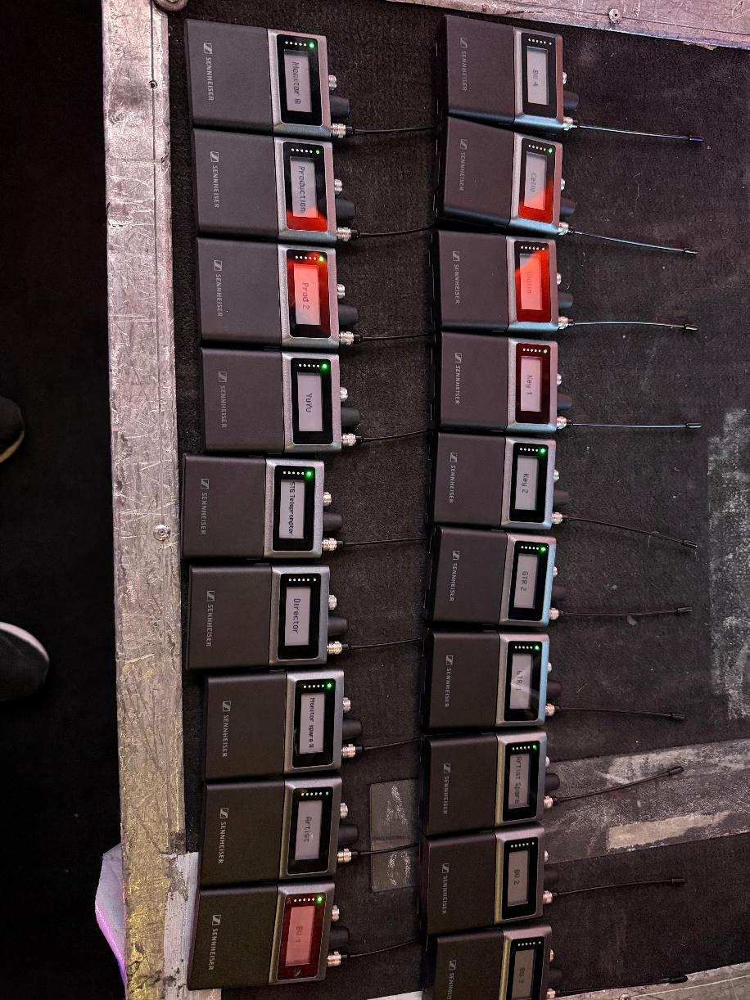
Favian first deployed Spectera at a major stop on the tour as part of the Sennheiser Spectera Pioneer Programme

With Spectera, antennas could be placed strategically across the stage, including along the catwalk, delivering consistent RF performance throughout the performance area. The move from BNC cabling to CAT6 further simplified setup, enabling long cable runs without signal loss, a major advantage in large arenas and stadiums.

A new level of control for monitor engineers
Beyond RF stability, Spectera transformed Favian’s day-to-day monitor workflow. The system provides real-time feedback from each bodypack, including battery status, RF levels and connection status.

“With analogue systems, if something goes wrong on stage, you are guessing and troubleshooting endlessly,” he says. “There is no easy way to deduce whether it is the battery, the pack or just RF interference.”

Frequency coordination has never been more straightforward. Spectera requires only a 6 MHz bandwidth to operate. In contrast, traditional analogue systems consistently face challenges related to frequency allocation and intermodulation interference.

He also added, “As productions grow in scale and demand, additional wireless channels are often introduced, which increases the risk of intermodulation distortion and complicates the overall coordination process”.

Spectera, powered by Sennheiser WMAS technology, overcomes traditional coordination challenges by enabling multiple transceivers to operate concurrently in a single wideband RF channel. This is achieved through a combination of time division multiple access (TDMA), time division duplex (TDD) and orthogonal frequency division multiplexing (OFDM), maximizing RF efficiency. The result is a streamlined solution that supports expanding channel requirements without introducing interference or compromising performance.

One feature that quickly became essential was volume monitoring. During quick costume changes, artists’ packs may be unintentionally adjusted. Spectera allows Favian to remotely monitor the pack status and set levels, ensuring consistency throughout the show.

“My artist now feels very confident on stage,” he adds. “He knows the volume will always be exactly where it should be.”

For the artists themselves, the most noticeable change was sound quality. Moving from analogue to digital eliminated compression and expansion artefacts, resulting in a more natural and open sound.

“The stereo image is extremely wide,” Favian explains. “Left and right are truly independent, which lets me space my instruments creatively.”

This clarity proved especially valuable for vocal-led performances. With instruments spread cleanly across the stereo field, vocals remained centred and unobstructed, helping artists hear more clearly and perform with greater comfort.

Built for touring reality
Favian currently runs 22 Spectera bodypacks with two Base Stations. Different audio modes are used based on performer needs, with ultra-low latency reserved for the artist and monitor engineer, while other musicians and the production crew operate on low-latency or live modes.

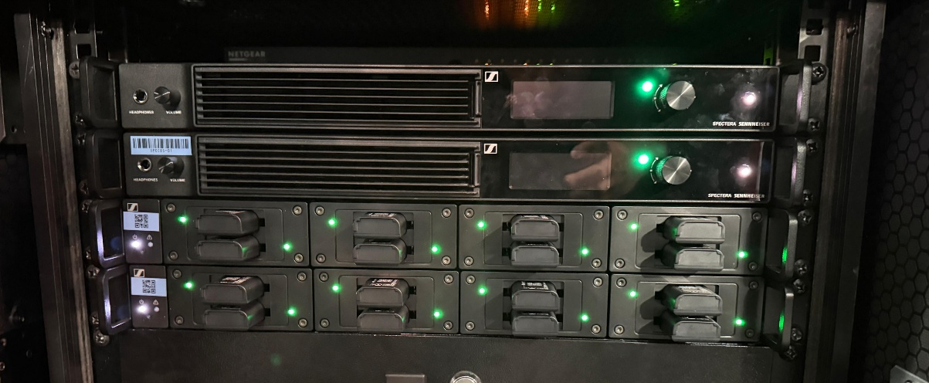
Favian currently runs 22 Spectera bodypacks on two Base Stations

“Latency remains a critical consideration for performers, particularly singers and musicians. Spectera sets a new benchmark with an exceptionally low IEM latency of just 0.7 milliseconds, which is the lowest available in any digital wireless in-ear monitoring system”, Favian explains. “This latency is vital for vocalists as it helps minimise bone-conduction interference and reduces the risk of comb filtering effects.”

From a logistics perspective, Spectera’s compact footprint also streamlines touring. Each system occupies just one rack unit, making transportation significantly more efficient than traditional systems.

Spectera is an IP-based system that enables full control through a web user interface. “The ability to manage Spectera via the Spectera WebUI has been a game changer,” Favian notes. “I can walk around the venue with my iPad, or even just a phone, and can instantly view the status of every pack and antenna.”

A partnership that evolves
Adopting Spectera early meant working closely with Sennheiser’s technical team as the system continued to evolve. Regular firmware updates and hands-on support ensured stability and continuous improvement throughout the tour.

“The support has been very strong from the Sennheiser team,” Favian says. “They listened to my feedback and responded quickly.”

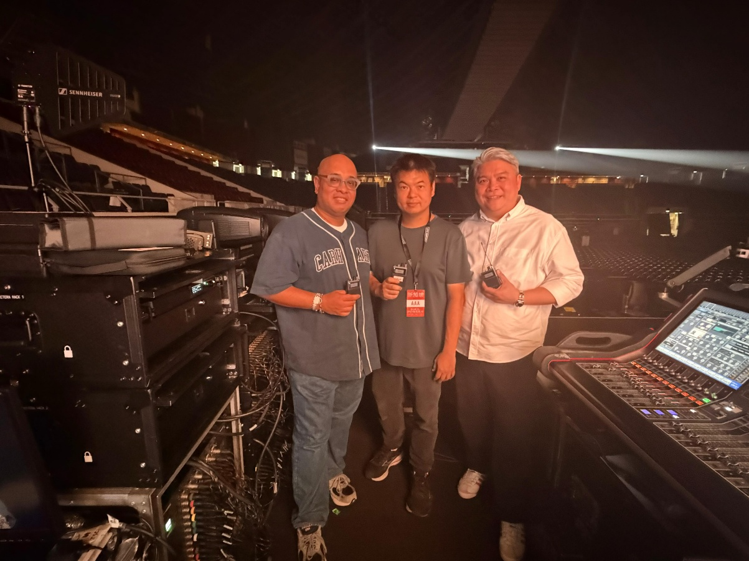
(from left to right) Darryl Tan, Business Development Manager at Sennheiser Asia, Favian Ngan, Founder of AV Production, and Gerald Fong, Projects and Sales Director at Concept Systems during the Singapore stop of an international world tour held at the Singapore Indoor Stadium

Behind the scenes, the transition to Spectera was supported by close collaboration between AV Production, Sennheiser and Concept Systems, Sennheiser’s preferred partner for Spectera in Singapore. From RF planning guidance to workflow optimisation and system configuration, the local team played a critical role in accelerating adoption. Combined with direct technical engagement from Sennheiser’s technical application engineering team, the partnership ensured that AVP not only integrated Spectera smoothly into its touring setup but could also maximise its capabilities across increasingly complex international show environments.

Spectera has now become a core part of Favian’s touring workflow, and one he now actively recommends to peers.

“When you compare it side by side with other systems, you can clearly hear the difference,” he says. “But beyond sound quality, it is the control, RF stability and confidence it gives you during a show.”

For AV Production and Favian, Spectera is no longer an experiment. It is an essential tool, redefining what is possible for modern touring and large-scale live productions.

(Ends)

The images accompanying this media release and an additional photo can be downloaded here.

About the Sennheiser brand
We live and breathe audio. We are driven by the passion to create audio solutions that make a difference. Building the future of audio and bringing remarkable sound experiences to our customers – this is what the Sennheiser brand has represented for 80 years. While professional audio solutions such as microphones, meeting solutions, streaming technologies and monitoring systems are part of the business of Sennheiser electronic SE & Co. KG, the business with consumer devices such as headphones, soundbars and speech-enhanced hearables is operated by Sonova Holding AG under the license of Sennheiser.

www.sennheiser.com
www.sennheiser-hearing.com

Press Contact
Su Hui Phang
suhui.phang@sennheiser.com
M +6569325930

